User Preferences for Animation and Speech Properties: A Survey Study for Developing a Smart Reminder to Facilitate Wheelchair Power Seat Function Usage

Hsin-yi Liu^{1,2}, Garrett Grindle^{1,2}, Fu-Chieh Chuang³, Annmarie Kelleher^{1,2}, Rosemarie Cooper^{1,2}, Dan Sieworek³, Asim Smailigic³, Rory A. Cooper^{2,1}

¹Department of Rehabilitation Science and Technology, University of Pittsburgh, ²Human Engineering Research Laboratories, Department of Veterans Affairs, ³Carnegie Mellon University, Pittsburgh, Pennsylvania
ABSTRACT
This study consisted of conducting a survey of users’ preferences for interface modalities and reminder functions to develop a seating virtual coach (SVC). The subjects reviewed animation and speaking with various properties using a computer demonstration program with supplemental devices. Their preferences and suggestions were collected via a questionnaire and interviews. An animation of power seat function usage tasks was preferred because it conveyed essential information. If human face images and speaking are needed, female images and voices were preferred more frequently than male. The information obtained from this study will be used to design human-machine interface and reminder functions.
KEYWORDS: feedback; power seat function; user preference; virtual coach
INTRODUCTION
With advances in technology and ergonomic design of portable computers and cell phones, personal digital devices have become an important medium for delivering education materials or persuading people to make health behavior changes. Task coaching systems have been created to enhance health behavior or to give guidance for daily or vocational tasks (1-4).
Selections of interface modalities for a coaching or reminding system can influence users’ adherence, which determines the effectiveness of the system/device. The modality and features must be varied according to the target populations and tasks (5,6); therefore, user abilities and preference should be considered at the early stage of media design for an interface (7).
Power seat functions (PSFs) provide power wheelchair users an independent means of adjusting their postures to decrease the risks of secondary conditions (e.g., pressure sores, contractures, venous pooling, spasticity) and assist with daily tasks, such as transferring and reaching objects (8). Appropriate PSF usage includes proper timing, sequences, and amplitudes (9), which are difficult for some users to learn and memorize within a short time period. We are developing a smart reminder, a Seating Virtual Coach (SVC), to monitor PSF usage and provide feedback for prompting the user to appropriately operate PSFs. In this study, PSF users were surveyed to determine their preferences for animation and speech for conveying the feedback of the SVC. The information obtained from this study will provide a framework to develop a useful prototype.
METHOD
PSF users and clinicians were recruited as our participants. The PSF user subjects had to be over 18 years of age, experienced with using PSFs, and able to operate seat functions independently. The information about this study was distributed through study flyers were posted in the Center for Assistive Technology and the Human Engineering Research Laboratories (HERL) newsletter. A computer demonstration program was developed for the subjects to review different modalities with various properties (Table 1), but only the results about the preference for animation and speech are presented in this paper. The program presented the modalities with four different themes: reminding, warning, giving guidance, and giving encouragement. The content and form of speech and text were altered according to the theme selected. Figure 1 shows the menu selection options of the computer program. Human face animations were not included at this stage of development, static female and male faces (10) were used to simulate the effect of the face animations. Cartoon animations were from Microsoft Agent Animations. A questionnaire was developed to collect subject preferences for modalities. Subjects were asked to rank their preferred properties of the animations and speech. After a subject tried the different modalities in each theme, they provided their responses to the questionnaire. This study was reviewed and approved by the Institutional Review Board of the University of Pittsburgh.
Descriptive statistics were reported for observing the trends in selecting modalities and properties and subjects’ attitude toward the SVC. The Chi-square (X²) test was chosen to analyze the significance of rankings. The significant level (α) was set at .01 to adjust for multiple measurements.

Table 1: The interface modalities in the demonstration program
Sensory Group | Modalities | Properties
Audio | Beeping | -
Audio | Melody | -
Audio | Speaking | Cartoon (long/short); Female (long/short /emotional/calm); Male (long/short /emotional/calm); Monotonic(long/short)
Visual | Light | -
Visual | Static sign | Collective signs commonly used for the four themes
Visual | Animation | Cartoon; Female face; Male face; Task of using PSFs
Visual | Text | Short: keywords or direct command  Long: include more detail information
Somatic | Vibration | -
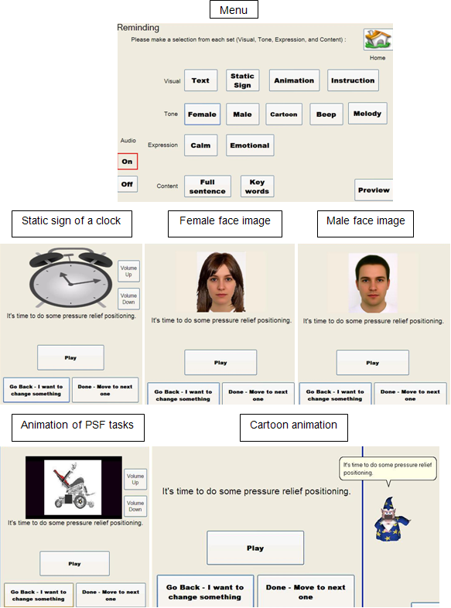
Figure 1: The menu and selection result display of the computer program

RESULTS
Nine PSF user subjects and six clinician participants were recruited. Their demographic information is shown in Table 2. The results of the questionnaire are shown in Table 3 and Table 4. Although not statistically significant, most subjects gave cartoon animations or PSF task animations higher rankings than human face animations. The subjects were prone to select short content in the reminding, warning, and giving encouragement themes. More subjects selected the short content for the reminding and warning themes, but selected the long content for giving guidance.

Table 2: Subject demographic information
 |  | PSF users (n=9) | Clinicians (n=6)
Gender | Female | 3 | 5
Gender | Male | 6 | 1
Age (years) | <30 | 2 | 1
Age (years) | 30-50 | 5 | 4
Age (years) | >50 | 2 | 1
Profession | Physical Therapist | -- | 4
Profession | Occupational Therapist | -- | 2
Diagnosis | Spinal Cord Injury | 4 | --
Diagnosis | Muscular dystrophy | 2 | --
Diagnosis | Cerebral Palsy | 2 | --
Diagnosis | Multiple Sclerosis | 1 | --

Table 3. The percentage of subjects ranking each animation and speech properties
Ranking of Speaking Property | Male | Female | Cartoon | Monotonic
1 | 33.3 | 33.3 | 26.7 | 6.7
2 | 20.0 | 33.3 | 26.7 | 20.7
3 | 33.3 | 20.0 | 20.0 | 26.7
4 | 13.3 | 13.3 | 26.7 | 46.7

Ranking of Animation Property | Female face | Male face* | Cartoon | PSFs task
1 | 0 | 6.7 | 33.3 | 53.3
2 | 20.0 | 6.7 | 46.7 | 33.3
3 | 53.3 | 20.0 | 6.7 | 6.7
4 | 26.7 | 66.7 | 13.3 | 6.7

- * p< .01

Table 4: The percentage of subjects selecting the sentence length and emotion expression for speech
 | Reminding | Warning | Giving guidance | Giving encouragement
Short + Calm | 53.3 | 33.3 | 46.7 | 26.7
Long + Calm | 20.0 | 13.3 | 53.3 | 20.0
Short + Emotional | 20.0 | 33.3 | - | 40.0
Long + Emotional | 6.7 | 20.0 | - | 13.3
DISCUSSION
Human animations, also known as virtual human agents or virtual agents, have been applied widely to improve user adherence to computer programs for training or educational purposes (11-14). However, our subjects did not show preferences for human face images. This may result from the main purpose of the SVC which is to monitor and guide the user to use the PSF more appropriately. Participants reported that the animation of the PSF tasks provided essential information and made the message more serious. Some subjects preferred cartoon animations for their entertaining characteristics which were different from traditional relationships of receiving instructions from another person. Comparing the female and male faces, subjects stated that the female face made them feel more comfortable. Subjects did not have a preference for either the male or female voices. The roles that vision and audition playing in perception may change according to experimental setting and context (15,16), but vision is the major source of recognizing emotions (17), thus more easily arousing emotional changes. The phenomenon observed in our study may be affected by how we presented the modality. Speech was accompanied with the messages from the SVC about appropriate PSF usage, giving the speaking a neutral property due to the seriousness of the context. In contrast, the static facial images could be dissociated from the messages, providing the subjects more freedom to interpret, even though there was no specific facial expression on both faces. However, users’ rejection of male voices was shown in a study of developing a hand-washing coaching system (18). Female voices and images may be more appropriate properties for animations or human agents of the SVC. We did not find statistically significant preference for speech tones and content length, but we did observe a trend that the subjects liked short sentences for reminding, warning, and giving encouragement and long sentences for giving guidance. This selection may indicate that subjects expected to obtain more detailed information when the SVC was giving guidance. Providing detailed information is a very supportive strategy at the beginning of learning new tasks. After each user gradually memorized the procedures and the tasks, the information remains important but the display may be redundant. Therefore, some clinicians suggested a leveraged solution that the interface can provide a “Help” option to present supplemental information when it is needed in the later learning stage. This alternative can keep speech and text succinct, but the SVC is still supportive when needed. Although the investigator asked each participant to share their preferences without being limited by our examples, some bias was difficult to be avoided. For example, it is unknown whether subjects will prefer human face images if we had presented different animations. This was a cross-sectional study, and subjects were entertained by changing modalities and properties using the computer program. User interface design preferences should be repeated when the take home trial of the subject testing for the SVC is conducted. A follow-up study will reveal more information about the appropriate multimedia interface modalities for real-time interactive reminder devices.

CONCLUSION
User preferences and suggestions collected from this study will be applied in developing the seating virtual coach. The information provided in this paper will serve as a reference for wheelchair manufacturers to design friendly control interfaces.

ACKNOWLEDGEMENTS
This study was supported by The Quality of Life Technology-Engineering Research Center, NSF, grant # EEC0540865.

REFERENCE
- IJsselsteijn, W. A., de Kort, Y. A. W., Westerink, J., de Jager, M., & Bonants, R. (2006). Virtual fitness: stimulating exercise behavior through media technology. Presence, 15(6), 688-698.
- Batthaicer, J. A. (2008). Training Toothbrush with Audio. United States Patent and Trademark Office. US. US 2008/0028553A1.
- McCue, M., Hodgins, J., F.LoPresti, E., & Bargteil, A. (2008). Telerehabilitation in employment/community supports using video-based activity recognition. 13th Annual International Meeting & Exposition of American Telemedicine Association, Seattle, Washington, USA.
- Mihailidis, A., Boger, J. N., Craig, T., & Hoey, J. (2008). "The COACH prompting system to assist older adults with dementia through handwashing: an efficacy study." BMC Geriatrics 8(28).
- Moreno, R., Mayer, R. E., Spires, H. A., & Lester, J. C. (2001). "The case for social agency in computer-based teaching: do students learn more deeply when they interact with animated pedagogical agents?" Cognition and Instruction 19(2): 177-213.
- Gerven, P. W. M. v., Paas, F., Merrienboer, J. J. G. v., & Schmidt, H. G. (2006). "Modality and Variability as Factors in Training the Elderly." Applied Cognitive Psychology 20: 311-320.
- Sutcliffe, A. G., Kurniawan, S., & Shin, J.-E. (2006). "A method and advisor tool for multimedia user interface design." International Journal of Human-Computer Studies 64: 375-392.
- Cook, A. M. and S. M. Hussey (2002). Seating Systems As extrinsic Enablers for Assistive Technologies. Assistive Technology: Principles and Practice, Mosby: 165-211.
- Dicianno, B. E., Margaria, E., Arva, J., Lieberman, J. M., Schmeler, M., Souza, A., et al. (2008). RESNA Position on the Appilication of Tilt, Recline, and Elevating Legrests. Arlington, VA, Rehabilitation Engineering & Assistive Technology Sciety of North America.
- Braun, C., Gruendl, M., Marberger, C., & Scherber, C. (2001). Beautycheck - Ursachen und Folgen von Attraktivitaet.
- Mohamad, Y., Hammer, S., Haverkamp, F., Noker, M., & Tebarth, H. (2002). "Evaluation study: training with animated pedagogical agents." Computer helping people with special needs: 3-25.
- Bickmore, T. W. and R. W. Picard (2005). "Establishing and maintaining long-term human-computer relationships." ACM Transactions on Computer-Human Interaction (TOCHI) 12(2): 293-327.
- Bickmore, T. W., Pfeifer, L. M., & Paasche-Orlow, M. K. (2007). Health Document Explanation by Virtual Agents. Lecture Notes in Computer Science, Springer. 4722: 183.
- Bickmore, T., Mauer, D., & Brown, T. (2009). "Context awareness in a handheld exercise agent." Pervasive and mobile computing 5(3): 226-235.
- Gelder, B. d. and J. Vroomen (2000). "The perception of emotions by ear and by eye." Cognition and Emotion 14(3): 289-311.
- Krahmer, E. and M. Swerts (2007). "The effects of visual beats on prosodic prominence: Acoustic analyses, auditory perception and visual perception." Journal of Memory and Language 57: 396-414.
- Dyck, M. J., Farrugia, C., Shochet, I. M., & Holmes-Brown, M. (2004). "Emotion recognition/understanding ability in hearing or vision-impaired children: do sounds, sights, or words make the difference?" Journal of Child Psychology and Psychiatry 45(4): 789-800.
- Mihailidis, A., Barbenel, J. C., & Fernie, G. (2004). "The efficacy if an intelligent cognitive orthosis to facilitate handwashing by persons with moderate to severe dementia." Neuropsychological Rehabilitation 14(1): 134-171.

Author Contact Information:
Hsin-yi Liu, MS, Human Engineering Research Laboratories (HERL), VA Pittsburgh Health System 7180 Highland Dr., Building 4, 2nd Floor East, 151R1-H, Pittsburgh, PA 15206, Office Phone (412) 954-5317. EMAIL: hsl16@pitt.edu

